Operational Concept Description (OCD)
Transportation Grant Fund Database
Team #14
Team Members | Roles
Kirill Khistyaev | Software Architect
Karim Sacre | Project Manager
Wenfeng Liu | Tester
Stephan Rice | IIV&V
Zhanna Seitenova | Life Cycle Planner
Ayman Khalil | Operational Concept Engineer

Date: April 26, 2012

Version History

Date | Author | Version | Changes Made | Rationale
Sep 18, 2011 | AK | 1.0 | - Added OCD document for the very first time | - Initial draft
Sep 26, 2011 | AK | 1.1 | - Updated section 2.5 | - Bug fixing (ID 4482)
Oct 9, 2011 | AK | 2.0 | - Added section 3.2, 3.3, 3.4  - Updated OCD Status section  - Updated Figure 2 (added LAN and an external system  - Updated Figure 1 (Fixed initiatives for various stakeholders)  - Updated Figure 3 (UML notation)  - Updated Section 2.3 after the win-win negotiation sessions | - Evolving the document as part of the Valuation Commitment package  - Reflect the current status of the OCD
Oct 14, 2011 | AK | 2.1 | - Fixed document footer  - Updated Section 2.2 as per the EPG template and the new win conditions  - Updated Table 3 (More operational capabilities)  - Updated Section 3.2.4  - Updated Section 2.4  - Removed General Public as a direct user of the new system  - Updated section 3.4.1 | - Developing the document for draft FCP package  - Bug Fixing (4831, 5456, 4920)
 | AK | 2.2 | - Revision of shared vision, business workflow, Element relationship diagram, Organizational and operational transformation  - Updated section 3.2.2 (level of service) | - Preparing for the final FCP package  - Bug fixing (5459, 5461)
Oct 23, 2011 | AK | 2.3 | - Updated benefits chain diagram to include explicit deployment initiative and updated the general stakeholders  - Updated System Boundary and Element Relationship diagrams to include External Website | - Responding to ARB comments and delivering final FCP  - Bug fixing (5820)
Nov 7, 2011 | AK | 2.4 | - Updated Figure 3 title  - Updated Figure 4 to exclude irrelevant process (maintain the system)  - Updated Figure 5 to add more clarity for the proposed system workflow | - Bug fixing (6061, 6062, 6064)
Nov 17, 2011 | AK | 3.0 | - Updated document version to 3.0 | - Draft DCP
Nov 30, 2011 | AK | 3.1 | - Updated ER, new business workflow & system boundary diagrams | - Preparing for DCR
Feb 2, 2012 | AK | 4.0 | - Updated document version to 4.0  - Introduced a projects coordinator as a new stakeholder (Updated Benefits Chain, System boundary, ER & new workflow diagrams)  - Introduced PM Central as part of TGF system | - Draft RDCP
Feb 17, 2012 | AK | 4.1 | - Updated document version to 4.1 | - RDCP
Mar 24, 2012 | AK | 5.0 | - Updated document version to 5.0 | - IOC1
April 26, 2012 | AK | 5.1 | - Updated OC-2 | - IOC2
Table of Contents
Operational Concept Description (OCD) i
Version History ii
Table of Contents iii
Table of Tables iv
Table of Figures v
1. Introduction 1
1.1 Purpose of the OCD 1
1.2 Status of the OCD 1
2. Shared Vision 2
2.1 Success-Critical Stakeholders 2
2.2 System Capability Description 3
2.3 Expected Benefits 3
2.4 Benefits Chain 4
2.5 System Boundary and Environment 5
3. System Transformation 6
3.1 Information on current system 6
3.1.1 Infrastructure 6
3.1.2 Artifacts 6
3.1.3 Current Business Workflow 8
3.2 System Objectives, Constraints and Priorities 8
3.2.1 Capability Goals 9
3.2.2 Level of Service Goals 9
3.2.3 Organizational Goals 10
3.2.4 Constraints 10
3.2.5 Relation to Current System 10
3.3 Proposed New Operational Concept 12
3.3.1 Element Relationship Diagram 12
3.3.2 Business Workflows 12
3.4 Organizational and Operational Implications 14
3.4.1 Organizational Transformation 14
3.4.2 Operational Transformation 14

Table of Tables
Table 1: Success-Critical Stakeholders 2
Table 2: Artifacts of the current system 6
Table 3: Operational Capability Goals 9
Table 4: Level of Service Goals 9
Table 5: Relation to current system 10

Table of Figures
Figure 1: Benefits Chain Diagram of Transportation Grant Fund Database 5
Figure 2: System Boundary and Environment Diagram of Transportation Grant Fund Database 6
Figure 3: Current system workflow for TGF projects reporting 9
Figure 4: Element Relationship Diagram for Transportation Grant Fund system 12
Figure 5: New system workflow for TGF projects reporting 13

1. Introduction
1.1 Purpose of the OCD
The purpose of OCD is to provide an early operational concept in order to achieve the shared vision of success critical stakeholders of Los Angeles Department of Transportation – Transportation Grant Fund Database project.
This document serves as an initial reference for articulating the overall system while the requirements and the system architecture are being shaped and also as an active reference during the development of the Transportation Grant Fund Database project.
The success-critical stakeholders for this project are William Halverson, as the Senior Management Analyst and the project owner, Project and Program Managers, Accountants as end users, Mony Patal and his team as system maintainers and we as software engineers and the 577a USC staff team as ICSM process champions.
1.2 Status of the OCD
This is version 5.1 of the OCD and it serves as a part of the final submission package. All document sections are completed.

2. Shared Vision
2.1 Success-Critical Stakeholders
Table 1: Success-Critical Stakeholders
Stakeholder | Authorized Representative | Organization | Relation to Benefits Chain
Project & Program Managers | William Halverson | LADoT | - Generating progress reports, quarterly report and expenditure reports
Accountants | William Halverson | LADoT | - Attach financial information to the projects
General Users (Grants Management Section, City Management, City Policy Makers) | William Halverson | LADoT | - Browse the different Grant Fund projects and generate the desired projects to free up staff from providing project information
Maintainers | Richard Harada & Mony Patal | LADoT | - Participate in product design, deployment and technical support
Projects Coordinator | Mony Patal | LADoT | - Create new Grand Fund projects and assign program managers
Development Team | Karim Scare | University of Southern California | - Develop the new system for the Transportation Grant Fund Database

2.2 System Capability Description
The system to be built is a web based Content Management System. Users of the system are LADoT program and project managers, accountants and general users who are responsible for Transportation Grant Fund process. The main purpose of the new system is to automate the current process of creating and updating grant projects. The system should be able to generate reports, basically quarterly reports and send email reminders about reports deadline to project managers. The system will also provide the ability for accountants to attach financial information to the project in the form of physical files (e.g. scan copies of invoices in PDF format).
The system should also provide security role based access control to different types of users. The system should also provide a rigid infrastructure for possible future expandability, such as adding project locations on maps and interfacing with external system.
2.3 Expected Benefits
- Consolidation of LADoT data at a centralized location

- System can guide the Grant Fund projects from inception to close out

- Save the time of the employee and therefore increase their productivity

- Minimize paper work (saves time and money)

- Easy access for different LADoT data

- Data storage will be minimal as the new system will eliminate the data duplication

- It will be easier to back up the grant fund data once everything is stored in one centralized data repository

- Scanned documents, such as finance related invoices, can be electronically attached to the related projects so that they can be easily retrieved

- The new system will serve as a fundamental infrastructure for the grant fund system that can be utilized for the future development purposes

- Provide greater transparency to different Transportation Grant Fund projects data

2.4 Benefits Chain
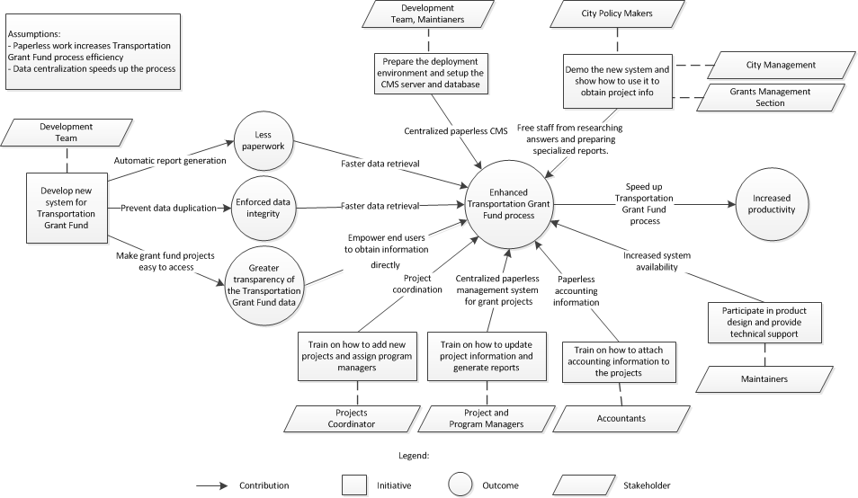
Figure 1: Benefits Chain Diagram of Transportation Grant Fund Database

2.5 System Boundary and Environment
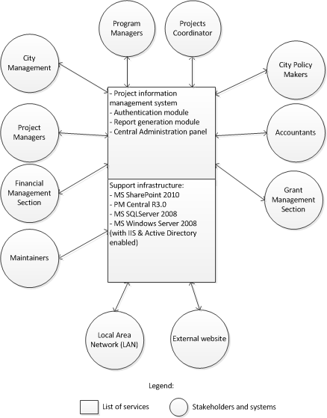
Figure 2: System Boundary and Environment Diagram of Transportation Grant Fund Database

3. System Transformation
3.1 Information on Current System
3.1.1 Infrastructure
The client currently has the following infrastructure, however, it is utilized using several systems (TGF Main, FMS, etc.), and however, most of the work is done manually:

Database: MS SQLServer and Oracle
OS: Windows 2008 servers (x64/x86)
Storage: SAN management
Development Environment: ASP.NET, C# and Microsoft SharePoint
Network: Secured lab infrastructure behind the firewall

3.1.2 Artifacts
Table 2: Artifacts of the current system
Artifact | Description
TGF 2010-2011 Signed by GM.pdf | Signed by General Manager, (GM) Department of Transportation; also known as "the Transportation Grant Fund Report"
09-1012_RPT_CAO_03-01-11.pdf | This document is the work product of the City Administrative Officer (CAO) who reviews the Transportation Grant Fund Report. It is the CAO Report however that is considered and adopted by City Council.
2010-2011 TGF Attachment A-Prop C revised.pdf  2010-2011 TGF Attachment B-Measure R revised.pdf | Attachments A and B. Attachments A and B is a list of transfers from Proposition C (or Measure R and perhaps other funding sources) to the Transportation Grant Fund No. 655. Both Attachments are generated by an existing Access Database that can be transferred over.
Copy of PC FUNDED PROJECT SUMMARY (9-7-10).xls | ACTIVE GRANT FUNDED TRANSPORTATION PROJECTS (YR. 1997-2009) - STATUS REPORT
LACMTA LOA ATTACHMENT D1 (hard copy) | This spreadsheet is maintained by the Grants Coordination Section and is frequently updated as information becomes available. This report also serves as the basis of Attachment A and Attachment B of the Transportation Grant Fund Report.
LACMTA MOU ATTACHMENT D1 (hard copy) | Quarterly progress report
Transmittal Letter (hard copy) | Quarterly progress report + Expense report
Transportation Grant Fund Process Workflow (hard copy) | Transmittal Letter + Metro MOU Attachment D1 + Direct Labor Report by Variation Code/Name

3.1.3 Current Business Flow
Figure 3: Current system workflow for TGF projects reporting
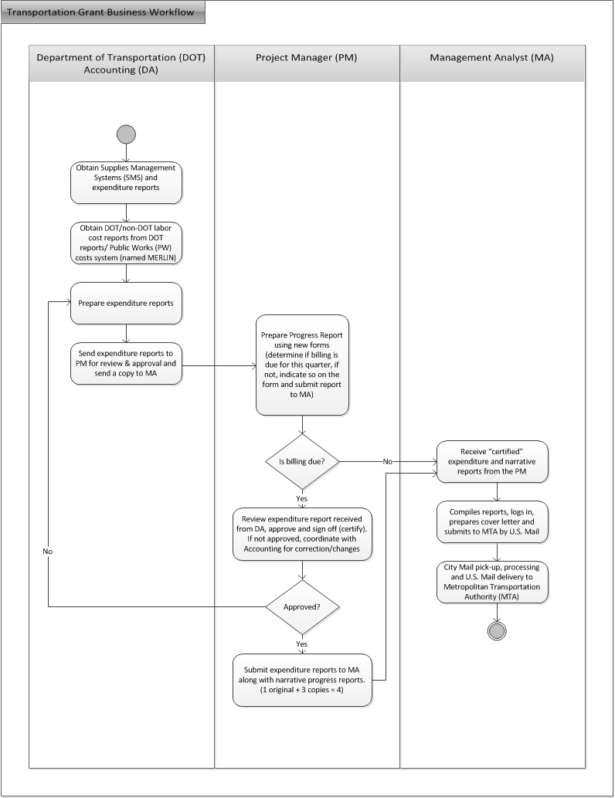
3.2 System Objectives, Constraints and Priorities
3.2.1 Capability Goals
Table 3: Operational Capability Goals
Capability Goals | Priority Level
OC-1 Role-based access control (RBAC): The system provides the capability of assigning predefined security roles to users | Must have
OC-2 Project coordinator approved user registration: The system provides the capability to the project coordinator to selectively approve user registration | Must have
OC-3 Electronically storing all project information: The system provides the capability of storing all project information and related attached documents electronically | Must Have
OC-4 Attaching documents: The system provides the capability of attaching physical files to the grant fund projects | Must have
OC-5 Report Generation: The system provides the capability of generating reports in easy to print format (Quarterly & progress reports) | Must Have
OC-6 Export project data: The system is capable of exporting grant fund projects data into XML standard format | Could Have
OC-7 Deadlines & notifications: The system provides the capability of setting deadlines for projects and sending reminders before certain due dates by email | Could Have
OC-8 Sending emails: The system provides the functionally of sending emails to the users of the system | Should Have

3.2.2 Level of Service Goals
Table 4: Level of Service Goals
Level of Service Goals | Priority Level
LOS-1 Number of users: The system will provide support for a minimum of 100 users and 50 concurrent user access | Must have

3.2.3 Organizational Goals
OG-1: Centralizing all grant fund project information in a single repository for ease of access and to avoid data duplication
OG-2: Increase the transparency of the grant fund project data and encouraging the target audience of these project to directly access these information
OG-3: Better utilization of the employees by releasing them form tasks that can be automated
3.2.4 Constraints
CO-1: Microsoft SharePoint Server as the Development Platform: The customer has already bought licenses for Microsoft SharePoint Server clearly set this constraint

3.2.5 Relation to Current System
Table 5: Relation to current system
Capabilities | Current System | New System
Roles and Responsibilities | - Maintainers have no direct contribution to the system  - Currently there is no role for Projects Coordinator | - Maintainers have to maintain and administer the new system (Create users, assign authorities, provide technical support)  - A new role, Projects Coordinator, is introduced. The person in charge will be responsible for creating new projects and assigning program managers*
User Interactions | - Project Managers manually collecting project information from different databases  - Accounts providing hard copies of the financial information | - Project Managers will use the system to generate reports  - Accountants attaching financial information to the projects
Infrastructure | - Different spreadsheets and databases | - Content Management System
Stakeholder Essentials and Amenities | - Paper work containing different project information | - Project information is electronically stored and can be edited/viewed
Future Capabilities | - Projects lack GIS information  - Google Apps are used independently | - Ability to add GIS information to the project so that they can be shown on maps  - Integrate Google Apps to the system  - Additional report types
* As of now, LADoT doesn’t have a Projects Coordinator role, and the system maintainers are in total charge of his responsibilities. However, a dedicated person will hold this responsibility in the future

3.3 Proposed New Operational Concept
3.3.1 Element Relationship Diagram
Figure 4: Element Relationship Diagram for Transportation Grant Fund system
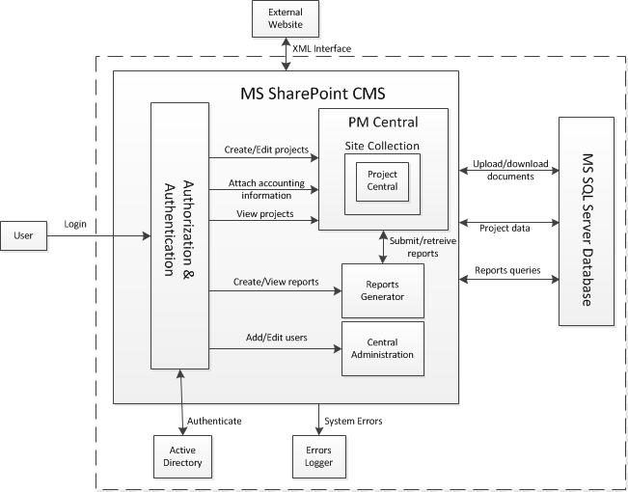
3.3.2 Business Workflows
The new system does not suggest a new business workflow; however, it will integrate to the current workflow by means of automating the process, rather than changing the flow of works. The Management Analyst workflow, with comparison to the old system, is not part of the new workflow.

Figure 5: New system workflow for TGF projects reporting
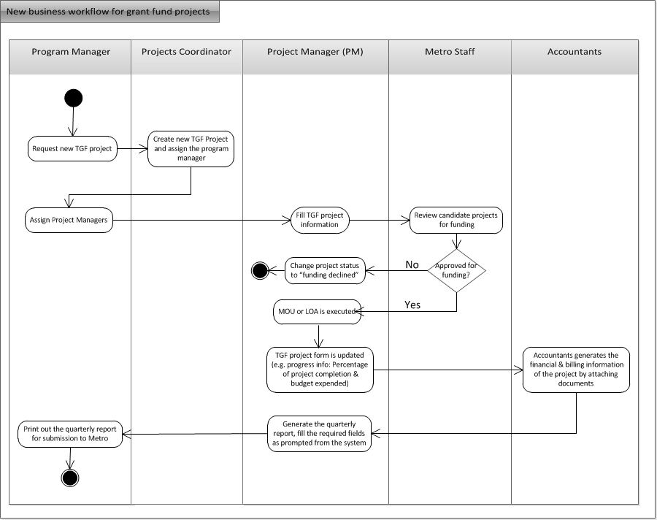

3.4 Organizational and Operational Implications
3.4.1 Organizational Transformation
- The elimination of multiple separate spreadsheets and hard copies of projects’ data
3.4.2 Operational Transformation
- Projects are to be created from the new system with all associated data, so separate spreadsheets and paperwork will be eliminated
- Progress reports, quarterly reports are now generated through the system, and will not be manually collected
- Project financial data are to be attached to the new system
- New users are to be defined in the system and assigned the proper roles

